“Київський фаховий коледж зв’язку”

Циклова комісія комп’ютерної інженерії

**ЗВІТ ПО ВИКОНАННЮ**

**WORK-CASE №5**

з дисципліни “Операційні системи”:

Виконали студенти

групи РПЗ-13А та РПЗ-13Б

Eleven Two Zeroes:

Vlad Sapozhnyk

Max Karpenko

Dmytro Onufriiev

Київ 2024

Робота студентів групи РПЗ-13А та РПЗ-13Б Eleven Two Zeroes: Vlad Sapozhnyk, Max Karpenko and Dmytro Onufriiev.

**Завдання:**

**1. При роботі з персональним комп’ютером дуже часто виникає необхідність підключати периферійне обладнання. На прикладі принтера та флешки опишіть який механізм має ОС Linux для роботи з ними.**

**- В чому суть операції монтування, для чого вона використовується та як?**

**- В чому різниця при роботі з периферією у ОС Linux та ОС Windows?**

In Linux, the mechanism for working with peripherals such as printers and flash drives differs from the approach used in Windows. The main differences are in the way devices are mounted and the file system is managed.

1. Mounting devices:

* The essence of the mount operation: In Linux, when you plug in an external device such as a flash drive or external hard disk, you must first "mount" the device so that the operating system can work with it. Mounting is the process of attaching the device's file system to the directory hierarchy on the system. Once the device is mounted, you can view and work with the files through a file manager or terminal.
* What is mounted for? Mounting is necessary for the operating system to be able to interact with external devices that are accessed through the file system.
* How it works: When a device is connected to a computer, the Linux kernel recognizes it and creates a corresponding device in /dev and provides access to it through a special file. The user or system then mounts the device to a specific directory using the mount command. After that, the user can work with the device as if it were a regular directory.

1. The difference between Linux and Windows:

In Windows, external device connections are usually automatically mounted, and the user simply receives a notification that the device is ready for use. In Linux, you usually need to manually mount the device.

In Windows, each device is given its own letter drive (e.g. C:, D:, E:), while in Linux, external devices are usually mounted in subdirectories of the system.

In Linux, users can use different file systems (such as ext4, NTFS, FAT32) without any restrictions, while in Windows, support for different file systems is limited.

**2. Підключіть до вашої віртуальної машини зі встановленою ОС Linux флешку та принтер (за можливості) та через графічний інтерфейс скопіюйте один файл з флешки на віртуальну машину та роздрукуйте його (такі ж самі дії повторіть, але з іншим файлом через команди в терміналі).**

Since we don't have a printer, we will show all this only with a flash drive.

To connect the flash drive to a virtual machine click the Devices tab at the top. Next, in the list, go to "USB" and find the name of your flash drive and click the checkmark.

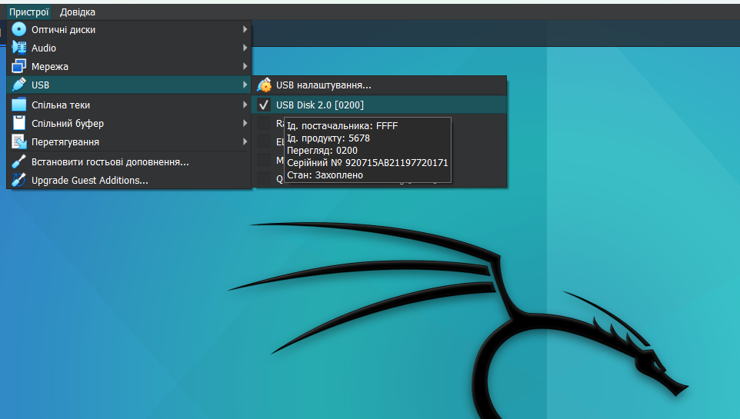

After that, a similar shortcut will appear on your desktop. This will mean that your flash drive is connected.   
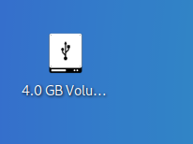

Click on it twice. After that, select the "Курсова робота" file and drag it to the desktop. Our file has been successfully copied.

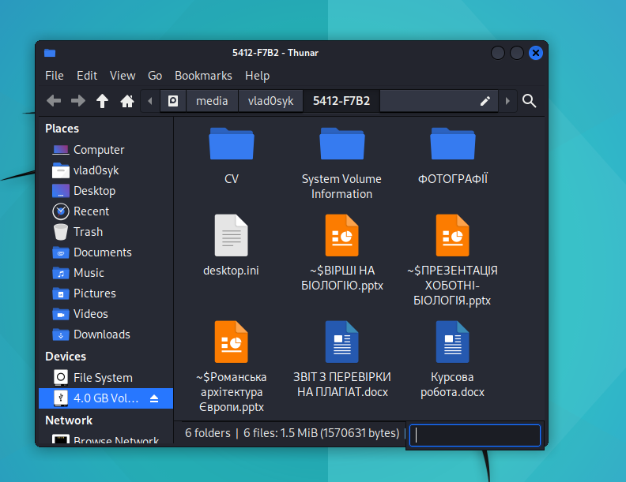

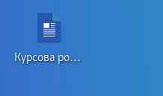

Let's do the same thing only in the terminal. To do this, create a "Test" file with the .txt extension on a flash drive and transfer it to the desktop.

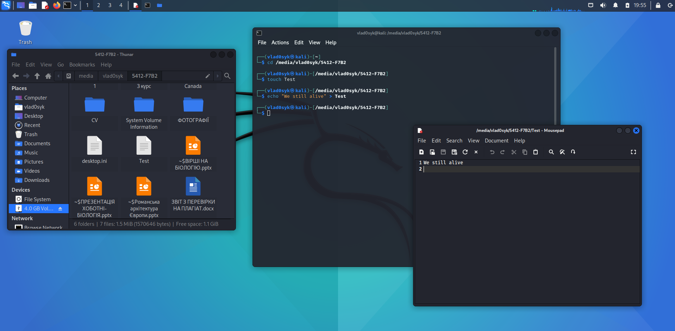

Now let's copy this file to the desktop.

